**Research Proposal**

**Mohsin 20589**



This **Research Proposal** is submitted to the Department of

Computer Science.

ABASYN UNIVERSITY PESHAWAR, Peshawar as on

**25 October 2022**

**(Author)**

**MOHSIN (BSSE)**

**Abstract:**

I need to design a desktop Application for billing calculation for a Pharmacy, which takes input from the user and calculates the total billing concerning predefined prices & subjects. This project must have different modules to make the decision of users simple & clear. This software must be based on 4 important sections (Customer Details, Medicine Details, Billing Section, and Bill Generate Phase). After data entry, this software gives a generate bill option to take the receipt in the form of Output.

**Introduction:**

In this Project, I am designing Billing Software as a Desktop Application that is used to take user input & select Medical items. This project contains many modules like Tablet Section, Syrup Section, Suspension Section, and Injections section. Each & every module will contain specific data about its category having price & quantity options. This option makes it simple & very useful to maintain time & fast response. This software will be based on **4** main sections. Customer Details, Medicines, Billing Section, and Bill Generate Section. This Software will be designed with Beautiful Fonts, an Interface & more attractive colors. This Software accepts data from the user and requires a specific quantity which will help it to calculate the price of medical kits. Each object will keep a specific price. In this Billing Software, I will add a module that especially works to generate the bill receipt for the customer. This software also contains Buttons to add more products, remove products from bills, and generate bills, and exit. The user interface of this Software will very simple and attractive which attracts users. After completing this project I will again modify it as per my requirements.

**Selection of Processing Model:**

In this Project, I will follow one of the advanced model known as the **Incremental Model** to achieve my requirements in a limited time.



**Objectives:**

* Customer Details Module
* Tablets Section
* Syrup Section
* Suspensions Sections
* Injections Module
* Billing Section
* Bill Generate Section
* Buttons (Add, Remove, Exit)

**Tools & Technology:**

* Visual Studio Code / Spyder / Pycharm
* Python

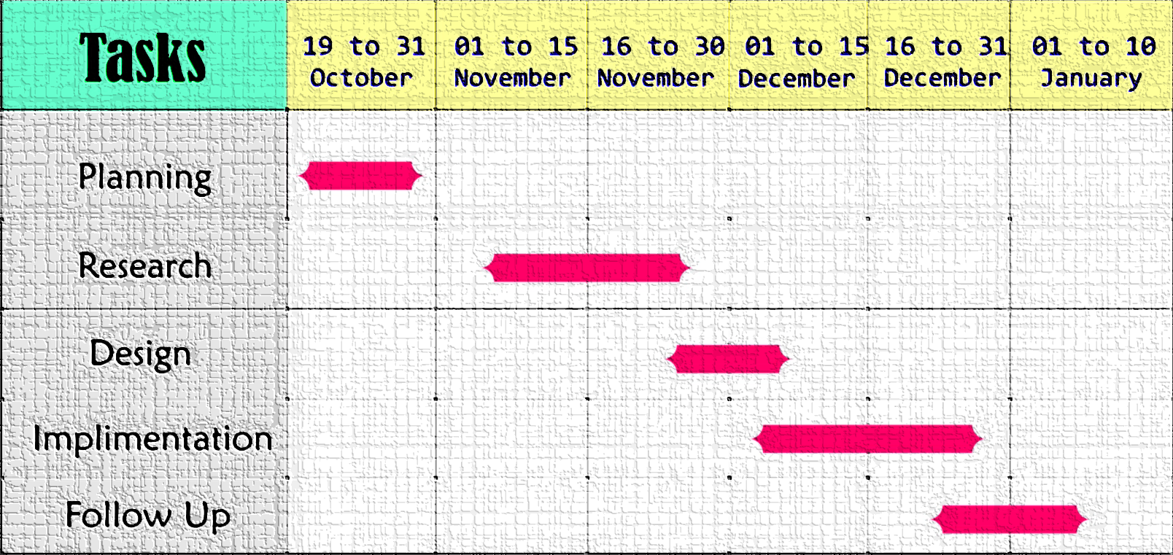**Gantt chart:**